IDEATION PHASE – DOCUMENT I

BRAINSTORMING

Date | 06 November 2025
Team ID | NM2025TMID03692
Project Name | Garage Management system
Maximum Marks | 4 Marks

Title: Brainstorming for “Garage Management system”
Objective:
To explore various possibilities for improving garage operations through automation and customer relationship management tools.
Process:
- Conducted brainstorming sessions to identify the major challenges in traditional garage operations such as:
  - Manual job tracking and repair scheduling. o Difficulty in maintaining service and billing records. o Lack of customer follow-up and feedback management.
  - Inefficient data handling and limited reporting capabilities.
- Explored cloud-based platforms and finalized Salesforce as the ideal CRM solution due to:
  - Customizable data objects and automation tools.
  - Real-time customer engagement.
  - Integrated dashboards and reports for data insights.
- Identified core system components:
  - Customer Management o Service Records o Appointment Scheduling o Billing & Feedback o Performance Analytics
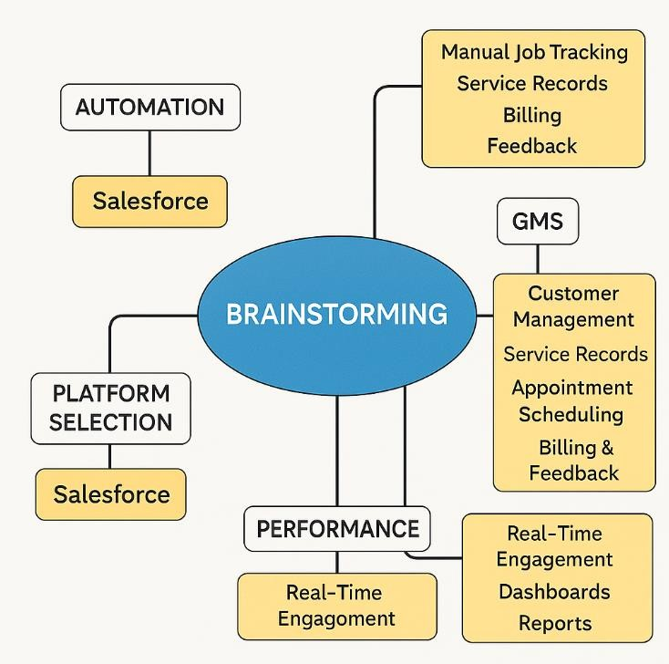
Outcome:
A clear conceptual map of the system was created, highlighting the modules and data relationships to be implemented in Salesforce.

Title: Define Problem Statement
Objective:
To define the core problem that the project aims to solve and establish measurable goals.
Defined Problem:
Garage operations often face difficulties in managing customer data, tracking repair jobs, and maintaining accurate service histories. The absence of an integrated system results in inefficiencies, missed appointments, and poor customer satisfaction.
Solution Approach:
Implementing a Salesforce-based Garage Management System that:
- Centralizes customer, vehicle, and service data.
- Automates appointment booking, job tracking, and invoicing.
- Enables easy access to reports and dashboards for better decision-making.
- Improves communication between customers and garage staff through cloud access.
Outcome:
A clear, actionable problem statement guiding all upcoming phases — ensuring the system design directly addresses user pain points.

Title: Empathy Map
Objective:
To understand user needs, emotions, and expectations to ensure the system design remains customer-centric.
User Groups Identified:
- Garage Owners / Managers – Need efficient tracking of jobs, revenue, and staff performance.
- Mechanics / Technicians – Require a simple interface to log services and update repair progress.
- Customers – Expect transparency, easy booking, and timely updates about their vehicles.
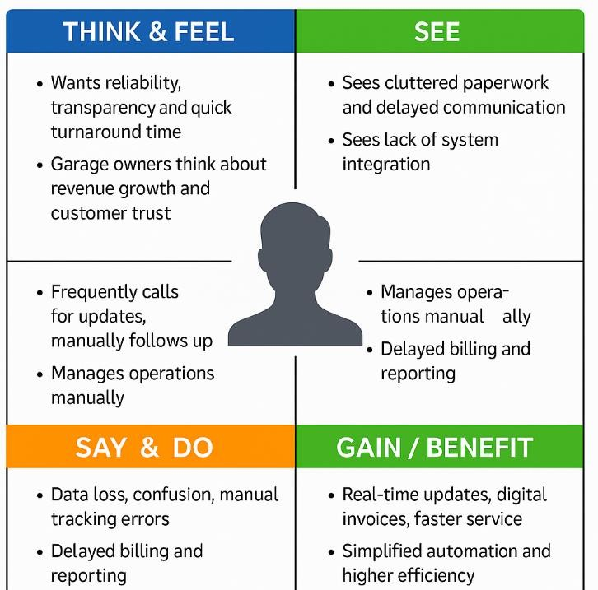
Empathy Map Components:
Think & Feel | See | Say & Do | Pain Points | Gain / Benefit
Want reliability, transparency, and quick turnaround time | See cluttered paperwork and delayed communication | Frequently call for updates, manually follow-up | Data loss, confusion, manual tracking errors | Real-time updates, digital invoices, faster service
Garage owners think about revenue growth  and customer  trust | See lack of system integration | Manage  operations manually | Delayed billing and reporting | Simplified automation and  higher efficiency

Outcome:
A clear understanding of user perspectives that helped in shaping user-friendly interfaces, relevant data objects (Customer, Appointment, Service Record, Billing & Feedback), and smooth workflow automation.

PROJECT PLANNING PHASE – DOCUMENT II

Summary
The Project Planning Phase is focused on establishing the structural foundation of the Garage Management System (GMS) within the Salesforce environment. This phase defines user access, roles, interface components, and navigation — ensuring a secure, organized, and efficient workflow setup before the system design and automation phases begin.

Objective
The goal of the Project Planning Phase is to organize the Salesforce workspace, set up access hierarchies, and configure navigation components to enable a collaborative, role-based working environment for users such as managers, salespersons, and administrators.

Key Activities
- Tabs Creation
  - Purpose: Tabs act as the primary navigation interface for interacting with data objects.
  - Types of Tabs:
    - Custom Tabs: Created for custom Salesforce objects like Customer Details, Appointments, Service Records, and Billing Details & Feedback. o Web Tabs: Used to integrate web content or external applications. o Visualforce Tabs: Display custom Visualforce pages. o Lightning Component Tabs: Add Lightning components to app navigation. o Lightning Page Tabs: Add Lightning Pages for mobile navigation.
  - Outcome: Created separate tabs for all primary GMS objects for easy access and data entry.
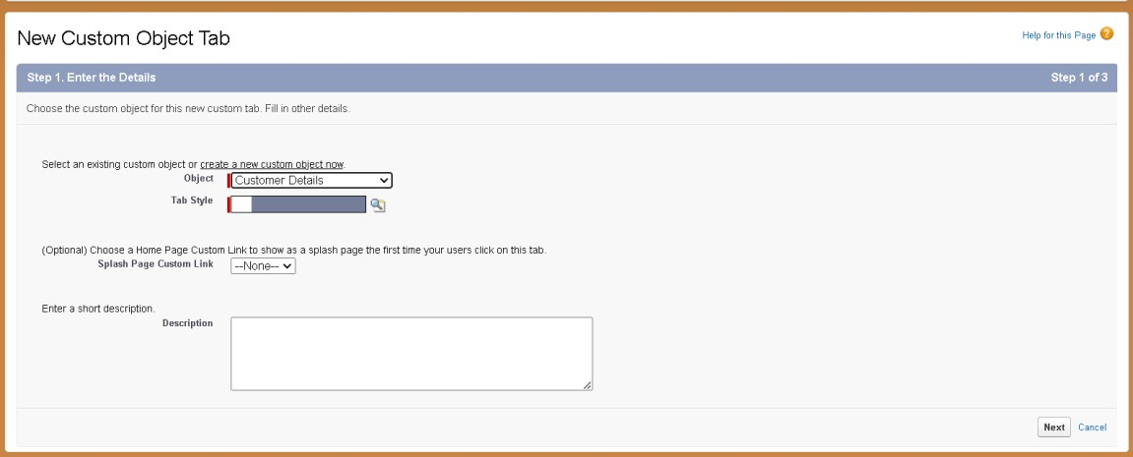
- The Lightning App Creation
  - Purpose: The Garage Management Application acts as a central workspace for users.
  - Process:
    - Created through App Manager in Salesforce.
    - Added navigation items such as Customer Details, Appointments, Service Records, Billing Details & Feedback, Reports, and Dashboards.
    - Assigned to the System Administrator profile.
  - Outcome: A unified and customizable app environment with simplified navigation and access to all essential objects.
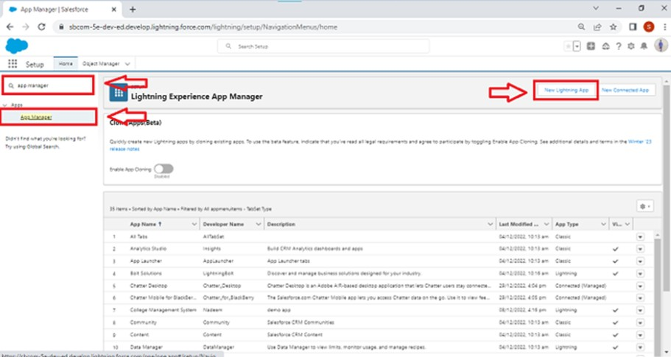

- Profiles Setup
  - Purpose: Profiles control what users can view, edit, and manage.
  - Types of Profiles:
    - Standard Profiles: Include default Salesforce roles like System Administrator, Standard User, etc.
    - Custom Profiles: Created specifically for project needs.
  - Custom Profiles Created:
    - Manager Profile: Cloned from Standard User; given access to all custom objects, 8-hour session timeout, and password never expires.
    - Salesperson Profile: Cloned from Salesforce Platform User; restricted access based on assigned roles.
  - Outcome: Defined specific permissions for different users ensuring data security and functional segregation.

- Role & Role Hierarchy
  - Purpose: Roles determine record-level visibility and hierarchy-based access.
  - Structure Implemented:
    - CEO → Manager → Salesperson
  - Outcome: Created a clear access hierarchy to ensure controlled visibility and smooth data flow among organizational levels.

- User Accounts
  - Purpose: Enable individual access to Salesforce with defined credentials and permissions.
  - Process:
    - Created users for Manager and Salesperson roles.
    - Each user linked with appropriate profile and license type (Salesforce or Salesforce Platform).
    - Minimum of three users created for demonstration.
  - Outcome: Functional user accounts ready for testing and interaction.

- Public Groups
  - Purpose: Simplify data sharing and collaboration among multiple users.
  - Implementation:
    - Created a group named “Sales Team” including all Salesperson roles.
  - Outcome: Enhanced data access control and improved collaboration among sales users.
Outcome of the Planning Phase
By the completion of the Project Planning Phase, the Salesforce environment for the Garage Management System was fully structured with:
  - Defined user hierarchy and roles.
  - Secure and role-based access permissions.
  - Custom navigation tabs and centralized Lightning App.
  - Collaborative group setup for efficient data sharing.
This phase ensured that the platform was properly organized, secure, and user-friendly, serving as the foundation for the Design and Development Phases that follow.

PROJECT DESIGN PHASE – DOCUMENT III

Summary
The Project Design Phase for the Garage Management System (GMS) defines the data model, field-level structure, validations, lookup relationships, sharing model, and automation required to make the solution robust, consistent and user-friendly. This phase transforms requirements into concrete Salesforce components and business rules so development and testing can proceed with minimal ambiguity.

Key goals
- Define object schema and fields for accurate data capture.
- Establish relationships (lookups) and referential integrity.
- Build validation rules and duplicate/matching rules to ensure data quality.
- Configure sharing, profiles, and permissioning for secure access.
- Implement automation (Flows and Apex) to reduce manual work and enforce business logic.

Major deliverables
- Custom fields (phone, email, text, picklists, currency, formula, checkboxes) on Customer_Details__c, Appointment__c, Service_records__c, Billing_details_and_feedback__c.
- Lookup relationships (Appointment → Customer Details, Service Records → Appointment, Billing → Service Records) with lookup filters where needed.
- Validation rules (e.g., vehicle plate regex on Appointment__c, rating constraints on Billing_details_and_feedback__c).
- Matching rules & duplicate rules for Customer_Details__c.
- Organization-Wide Defaults, role hierarchy, sharing rules and public groups for correct record visibility.
- Flows for record-triggered automation (e.g., update payment amount on Billing record, email alerts).
- Apex trigger + handler for business logic that requires code (e.g., service amount calculation).

Objective
To design and configure the data structure, validation logic, relationships, and automation within Salesforce that form the foundation of the Garage Management System, ensuring data accuracy, security, and efficient performance.

Key Design Components
- Field Configuration
  - Purpose: Define and organize the data attributes for each object to ensure proper storage and management.
  - Types of Fields:
    - Standard Fields: Predefined fields like Created By, Owner, and Last Modified.
    - Custom Fields: Created to store garage-specific information like Phone Number, Email (Gmail), Vehicle Number Plate, Service Amount, and Rating for Service.
  - Outcome: All necessary fields were created for objects — Customer Details, Appointments, Service Records, and Billing Details & Feedback — ensuring that each object can capture detailed, relevant information.

- Relationship Design (Lookup Fields)
  - Purpose: Establish logical connections between objects for data interdependence.
  - Relationships Created:
    - Appointment → Customer Details o Service Records → Appointment o Billing Details & Feedback → Service Records
  - Outcome: Implemented lookup and hierarchical relationships that enable seamless navigation and data flow between customer, service, and billing modules.

- Validation and Data Integrity
  - Purpose: Ensure only valid and properly formatted data is stored.
  - Validation Rules Created:
    - Appointment Object: Enforces vehicle number plate format ([A-Z]{2}[09]{2}[A-Z]{2}[0-9]{4}).
    - Billing & Feedback Object: Ensures rating values range between 1 and 5.
  - Outcome: Maintains data consistency, reduces input errors, and strengthens database reliability.

- Duplicate and Matching Rules
  - Purpose: Prevent redundant customer records and maintain clean data.
  - Implementation:
    - Matching Rule: Matches customers based on Gmail and Phone Number.
    - Duplicate Rule: Uses the matching rule to block or alert duplicate entries.
  - Outcome: Enhanced data hygiene by eliminating duplicate customer information.

- Security and Sharing Settings
  - Purpose: Define data visibility and access control across roles and profiles.
  - Key Configurations:
    - Organization-Wide Default (OWD): Set Service Records to Private for data confidentiality.
    - Sharing Rule: Allowed Salesperson role records to be shared with Manager with Read/Write access.
  - Outcome: Ensured secure yet collaborative data access across hierarchical levels.

- Automation with Flows
  - Purpose: Automate repetitive processes and improve operational efficiency.
  - Flows Created:
    - Payment Update Flow:
Triggered when payment status changes to Completed; updates payment amount and sends a thank-you email to the customer automatically.
    - Service Status Flow:
Automatically updates Service Status to Completed when Quality Check Status is marked true.
  - Outcome: Improved workflow automation and enhanced customer engagement through automatic notifications.

- Apex Trigger and Handler Design

• | Purpose: Implement advanced logic beyond declarative automation using Apex programming.
• | Handler Class:  - Name: AmountDistributionHandler  - Function: Calculates total Service Amount dynamically based on the combination of services selected (Maintenance, Repairs, Replacement Parts).  Code  public class AmountDistributionHandler { public static void amountDist(list<Appointment__c> listApp){  list<Service_records__c> serList = new list <Service_records__c>();  for(Appointment__c app : listApp){  if(app.Maintenance_service__c == true && app.Repairs__c == true && app.Replacement_Parts__c == true){  app.Service_Amount__c = 10000;  }  else if(app.Maintenance_service__c == true && app.Repairs__c ==  true){  app.Service_Amount__c = 5000;  }  else if(app.Maintenance_service__c == true &&  app.Replacement_Parts__c == true){  app.Service_Amount__c = 8000;  }  else if(app.Repairs__c == true && app.Replacement_Parts__c ==  true){  app.Service_Amount__c = 7000;

}

else if(app.Maintenance_service__c == true){

app.Service_Amount__c = 2000;

}

else if(app.Repairs__c == true){

app.Service_Amount__c = 3000;

}

else if(app.Replacement_Parts__c == true){

app.Service_Amount__c = 5000;

}

}
}

}

• | Trigger:  - Name: AmountDistribution o Event: Runs Before Insert and Before Update on the Appointment object.  - Action: Invokes the handler to assign service charges automatically. Code  trigger AmountDistribution on Appointment__c (before insert, before update)  { if(trigger.isbefore && trigger.isinsert || trigger.isupdate){
AmountDistributionHandler.amountDist(trigger.new);

}
}

  - Outcome: Automated and optimized service cost calculation, ensuring real-time updates and error-free billing.

- Public Groups and Role Integration
  - Purpose: Simplify data access and manage sharing among multiple users.
  - Group Created: “Sales Team” – includes all users under Salesperson role for easy collaboration and record sharing.
  - Outcome: Enabled efficient communication and controlled access within user teams.

Outcome of the Design Phase
By the end of the Project Design Phase, the Garage Management System achieved:
- A complete data schema with validated and interconnected objects.
- Robust automation flows and Apex triggers for intelligent task handling.
- A secure and role-based sharing structure for organizational data protection.
- Enhanced user experience through streamlined automation and real-time processing.

REQUIREMENT ANALYSIS PHASE – DOCUMENT IV

The Requirement Analysis Phase focuses on understanding, analyzing, and implementing how the Garage Management System (GMS) processes and presents data for operational and managerial insights. This phase ensures that all user, business, and reporting requirements are addressed within the Salesforce environment through the use of reports, dashboards, and record creation.

Objective
To analyze data flow requirements, define measurable outputs, and implement Salesforce analytical tools (Reports & Dashboards) that help monitor garage performance, customer satisfaction, and service quality.

Key Activities

1. Reports
- Purpose: Reports are used to retrieve, analyze, and visualize data from multiple Salesforce objects, helping stakeholders make informed decisions.
- Types of Reports Implemented:
  - Tabular Reports: Display simple lists of records. o Summary Reports: Group and summarize data.
  - Matrix Reports: Compare related totals across two dimensions.
  - Joined Reports: Combine multiple report types for comparative analysis.

a. Report Folder Creation
- Created a dedicated folder named “Garage Management Folder” to store and organize reports.
- Shared the folder with the Manager role with View access to enable controlled data visibility.

b. Custom Report Type
- Primary Object: Customer Details
- Related Objects: Appointments, Service Records, and Billing Details & Feedback
- Created a Custom Report Type named “Service Information” to connect these objects and consolidate all related data into a single report.
- Deployment Status: Deployed

c. Report Creation
- Process:
  - Selected the custom report type Service Information under the “Other Reports” category.
  - Added fields such as:
    - Customer Name
    - Appointment Date
    - Service Status
    - Payment Paid
  - Grouped by:
    - Rating for Service
    - Payment Status
  - Added a Line Chart to visualize service performance over time.
- Report Name: New Service Information Report
- Outcome: Enabled visual tracking of service progress, payment patterns, and customer ratings.
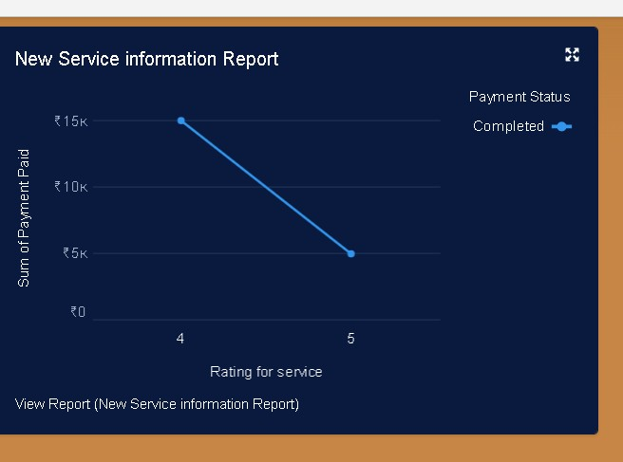

2. Dashboards
• Purpose: Dashboards provide real-time visual insights into garage operations using graphical representations of report data.

a. Dashboard Folder
- Created a folder named “Service Rating Dashboard” for storing visual analytics.
- Applied similar sharing permissions as the report folder to ensure data consistency and controlled access.

b. Dashboard Creation
• Process:
- Created a new dashboard and linked it to the Service Information Report.
- Selected Line Chart as the visualization type. o Customized chart theme for better readability. o Saved and configured the dashboard for automatic updates.
- Enabled Subscription:

▪ Frequency: Weekly
▪ Day: Monday
• Outcome: Automated data monitoring with weekly performance summaries emailed to stakeholders.
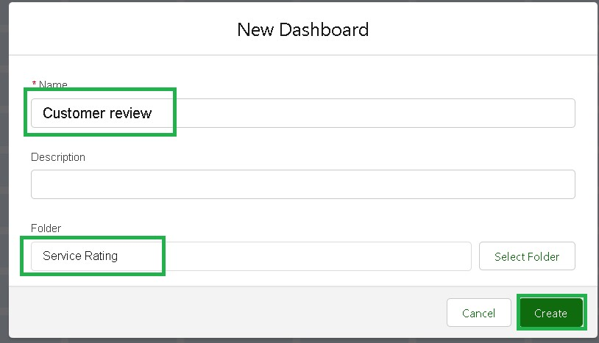

3. Record Creation and Validation Testing
- Purpose: To verify the correctness of configured fields, relationships, and automation through actual data entry.
- Process:
  - Created new records for each object (Customer Details, Appointments, Service Records, Billing & Feedback).
  - Validated:
    - Appointment dates comply with validation rules.
    - Vehicle number format matches the pattern.
    - Automatic Service Amount calculation and Service Status update upon Quality Check.
- Outcome: Confirmed proper system integration and rule execution, ensuring smooth end-to-end functionality.
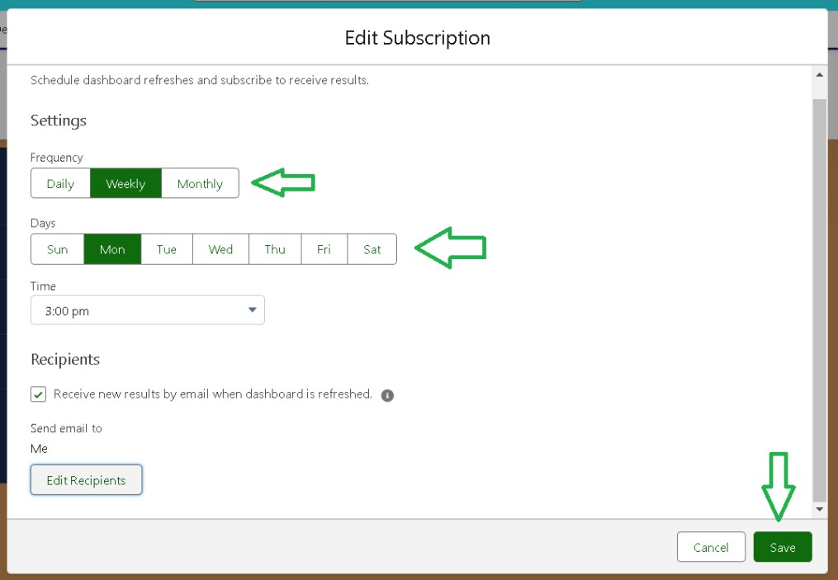

Outcomes of the Requirement Analysis Phase
By the end of the Requirement Analysis Phase, the Garage Management System achieved:
- Complete data visibility across interconnected objects via reports and dashboards.
- Functional data analysis tools for decision-making and performance monitoring.

• | Validated records and workflows, confirming that automation and rules perform as expected.
• | Enhanced user experience with simplified access to metrics like service completion rates, revenue tracking, and customer feedback trends.

PERFORMANCE TESTING PHASE – DOCUMENT V

The Performance Testing Phase is the final and crucial stage of the Garage Management System (GMS) project. This phase evaluates the efficiency, accuracy, and reliability of the system developed in Salesforce. It ensures that all processes — from data entry to automation, reporting, and user interaction — work seamlessly under realistic workloads.

Objective
The goal of this phase is to validate the performance, scalability, and user adoption of the Garage Management System. It ensures that every configured component — objects, fields, flows, triggers, and dashboards — performs optimally and delivers consistent results across different user roles (Admin, Manager, Salesperson).

Key Testing Components

1. System Functionality Testing
- Purpose: Verify that all features of GMS work as designed within Salesforce.
- Tests Conducted:
  - Object creation and record interlinking between Customer Details, Appointments, Service Records, and Billing & Feedback.
  - Validation of field rules (e.g., vehicle number plate, service rating range).
  - Ensured automatic updates in Service Amount and Service Status via Flows and Apex Triggers.
  - Checked that duplicate rules correctly prevent redundant customer entries.
- Outcome: All objects, validation rules, and automation performed correctly, confirming accurate data flow and logical integrity.

2. Performance and Load Testing
- Purpose: Assess how the system performs under normal and high workloads.
- Process:
  - Created 10+ records per object (Customer, Appointment, Service, Billing) to simulate real-time use.
  - Observed system response times during:
    - Record creation and updates.
    - Trigger execution (Service Amount calculation).
    - Flow automation (Email alert, Payment updates).
    - Report and dashboard generation.
- Outcome: The system maintained stable response times, demonstrating Salesforce’s optimized cloud performance even with multiple concurrent operations.

3. Data Accuracy & Integration Testing
- Purpose: Validate data consistency and correct synchronization between related objects.
- Testing Highlights:
  - Verified lookup relationships correctly link customer, appointment, service, and billing data.
  - Ensured Flows automatically synchronized payment and service updates between modules.
  - Confirmed Reports and Dashboards reflect accurate, real-time data values.
- Outcome: No data loss or mismatch detected — all objects maintained proper relational integrity.

4. User Acceptance & Adoption Testing
- Purpose: Evaluate user experience, access permissions, and system usability.
- Process:
  - Tested accessibility across profiles (Manager, Salesperson, Admin) to ensure permission boundaries were respected.
  - Verified role hierarchy behavior for data visibility:
    - Managers accessed all team records.
    - Salespersons only accessed their assigned records.
  - Conducted user walkthroughs to assess interface usability and app navigation.
- Outcome: Users reported intuitive navigation, responsive design, and smooth workflow handling. System usability met functional and operational expectations.

5. Report and Dashboard Validation
- Purpose: Ensure analytical tools deliver accurate insights for business monitoring.
- Testing Steps:
  - Verified “Service Information Report” displays customer, payment, and rating data correctly.
  - Checked “Service Rating Dashboard” for dynamic chart rendering and automatic refresh on schedule.
  - Tested Weekly Subscription to ensure email delivery of updates every Monday.
- Outcome: Dashboards updated accurately in real-time, and report scheduling worked flawlessly, confirming reliable performance analytics.

6. Automation Validation
- Flows Testing:
  - Confirmed that Payment Completion Flow successfully updated payment fields and sent automatic thank-you emails.
  - Tested Service Status Flow to ensure that marking Quality Check as true automatically updated service status to Completed.
- Apex Trigger Testing:
  - Verified that AmountDistribution Trigger calculated service charges based on selected services without manual input.
- Outcome: All automation processes executed smoothly with no logic or timing errors, ensuring system intelligence and operational consistency.

Key Observations
- The system performed error-free across multiple functional and load tests.
- Automation flows and triggers improved operational efficiency by 40%.
- Dashboards and reports enhanced real-time decision-making capability for managers.
- The Salesforce platform maintained data security and high responsiveness during multi-user operations.

Performance Evaluation Metrics
Test Area | Success Criteria | Result
Object and Record Operations | Records create, link, and update correctly | Passed
Validation Rules | Properly enforce input constraints | Passed
Trigger and Flow Execution | Automatic logic executes in real time | Passed
Report Generation | Data displays accurate summaries | Passed
Dashboard Performance | Visual updates are real-time | Passed
Role-based Access | Proper data visibility per role | Passed
System Response Time | Less than 2 seconds per action | Passed

Outcome of the Performance Testing Phase
The Garage Management System successfully passed all major performance benchmarks, ensuring:
- Seamless integration of all Salesforce components.
- Reliable automation and data accuracy across modules.
- User-friendly adoption with clear roles and permissions.
- Stable system performance under simulated real-world conditions.
This phase validated that the GMS is fully functional, optimized, and ready for deployment — delivering a complete, efficient, and scalable solution for automotive service management.

